**LAB-6**

NAME:K.Viswanadh Chowdary

ROLL_NO.:22MC3018

T1. Develop a single page application for Shopping List. First develop a simple prototype using html and javascript. Gradually develop a MVC based prototype.

HTML CODE:

<!DOCTYPE html>

<html lang="en">

<head>

<meta charset="UTF-8">

<meta name="viewport" content="width=device-width, initial-scale=1.0"> <title>Shopping List</title>

</head>

<body>

<h1>Shopping List</h1>

<input type="text" id="itemInput" placeholder="Add item"> <button onclick="addItem()">Add</button>

<ul id="itemList"></ul>

<script>

**let** shoppingList = [];

**function** addItem() {

**const** itemInput = document.getElementById("itemInput");

**const** newItem = itemInput.value.trim();

if (newItem !== "") {

shoppingList.push(newItem);

itemInput.value = "";

displayItems();

}

}

**function** displayItems() {

**const** itemList = document.getElementById("itemList");

itemList.innerHTML = "";

shoppingList.forEach(item **=>** {

**const** li = document.createElement("li");

li.textContent = item;

itemList.appendChild(li);

});

}

</script>

</body>

</html>

OUTPUT:

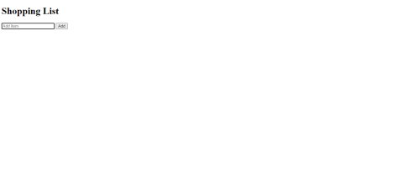

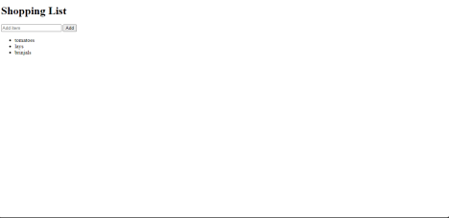

MVC Prototype Based CODE:

HTML:

<!DOCTYPE html>

<html lang="en">

<head>

<meta charset="UTF-8">

<meta name="viewport" content="width=device-width, initial-scale=1.0"> <title>Shopping List</title>

</head>

<body>

<h1>Shopping List</h1>

<input type="text" id="itemInput" placeholder="Add item"> <button id="addItemBtn">Add</button>

<ul id="itemList"></ul>

<script src="model.js"></script>

<script src="view.js"></script>

<script src="controller.js"></script>

</body>

</html>

model.js CODE:

**class** ShoppingListModel {

**constructor**() {

this.items = [];

}

addItem(item) {

this.items.push(item);

}

getItems() {

return this.items;

}

}

view.js CODE:

**class** ShoppingListView {

**constructor**(controller) {

this.controller = controller;

this.itemInput = document.getElementById("itemInput"); this.itemList = document.getElementById("itemList"); this.addButton = document.getElementById("addItemBtn"); this.addButton.addEventListener("click", () **=>**

this.controller.addItem(this.itemInput.value));

}

displayItems(items) {

this.itemList.innerHTML = "";

items.forEach(item **=>** {

**const** li = document.createElement("li");

li.textContent = item;

this.itemList.appendChild(li);

});

}

}

controller.js CODE:

**class** ShoppingListController {

**constructor**(model, view) {

this.model = model;

this.view = view;

}

addItem(item) {

if (item.trim() !== "") {

this.model.addItem(item.trim());

this.view.displayItems(this.model.getItems());

this.view.itemInput.value = "";

}

}

}

**const** model = new ShoppingListModel();

**const** view = new ShoppingListView(new ShoppingListController(model, view));

OUTPUT:

